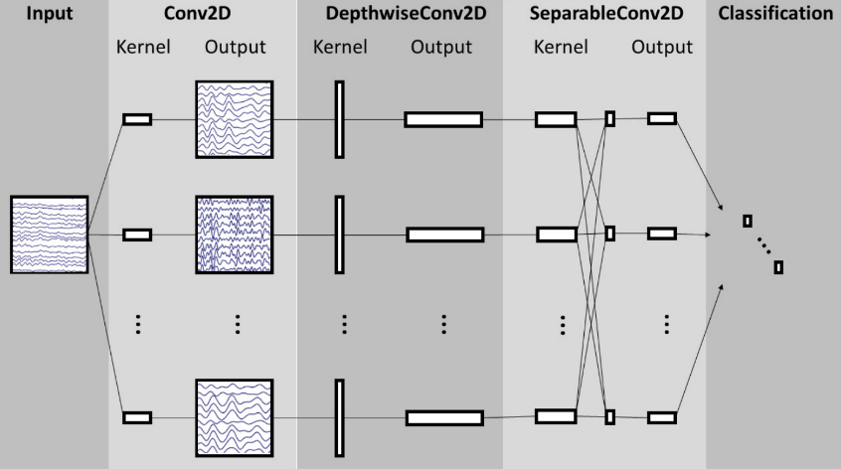
EEGNet is a compact ANN architecture for EEG-based BCI decoding, using ReLU activations throughout its temporal, depthwise, and separable convolutional blocks. This project tests how well EEGNet translates into a spiking neural network (SNN) by replacing every ReLU with a Leaky Integrate-and-Fire (LIF) neuron, which accumulates input over time and emits a discrete spike once its membrane potential crosses a threshold. The central question: does a direct, untuned ReLU→LIF conversion preserve performance, and if not, which hyperparameters need to change to recover it — and which ones matter differently for the ANN vs. the SNN version of the same architecture.
The dataset used, a four-class motor imagery dataset known as BCI Competition IV 2a, contains 9 subjects, and a new model is trained on 8 subjects and tested on the single left-out subject, giving a balanced accuracy. This is done for each subject and then averaged, giving LOSO mean balanced accuracy.
The experiment had three parts. The first was getting a baseline of EEGNet as an ANN. The second was getting a baseline of EEGNet as an SNN to measure the cost of a naïve conversion. The final part was using Optuna to search 14 architecture parameters and hyperparameters to see how much of the performance gap is recoverable and which parameters drive that recovery. This was done to explore which parameters are most important to change between ANN and SNN implementations of the same architecture.
There were 14 parameters searched for this experiment:
- LR_EXP: log10 of the learning rate. The actual learning rate is 10^LR_EXP. Controls how big each optimizer weight-update step is.
- DROPOUT: Fraction of activations randomly zeroed each forward pass to prevent overfitting.
- BETA: LIF neuron's membrane decay rate, which is how much memory a spiking neuron keeps between timesteps.
- SPIKE_GRAD_SLOPE: Steepness of the surrogate gradient used for back propagation through the spike function.
- TEMPORAL_FILTERS: Number of filters in the first convolutional layer that learn temporal patterns in the EEG signal.
- DEPTH_MULTIPLIER: How many spatial filters are learned per temporal filter in the depthwise convolutional layer. 2 means each temporal filter gets 2 spatial variants.
- POINTWISE_FILTERS: Number of output channels after the separable conv's 1x1 pointwise layer.
- TEMPORAL_KERNEL_DIV: Divisor used to compute the temporal convolutional kernel length based on input samples.
- SEPARABLE_KERNEL_SIZE: Length of the separable convolutional kernel.
- POOL1_SIZE: Downsampling factor applied after Block 1.
- POOL2_SIZE: Downsampling factor applied after Block 2.
- N_STEPS_TRAIN: Number of simulated timesteps the spiking network runs through during training.
- N_STEPS_EVAL: Same as above but used at evaluation/inference time.
- READOUT_MODE: How the per-timestep spike outputs are combined into a final prediction.
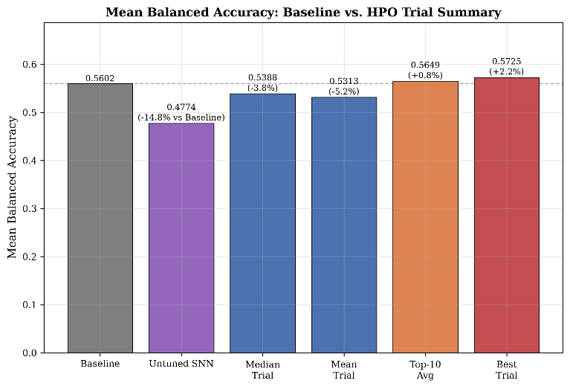
As expected, the conversion directly from ANN to SNN without any parameter tuning had a relative change of -14.8% vs the baseline, showing a drop in accuracy. The best trial from the Optuna study outperformed the ANN baseline with a relative change of +2.2%, showing the accuracy loss is fully recoverable. The median and mean trials both underperformed compared to the baseline.
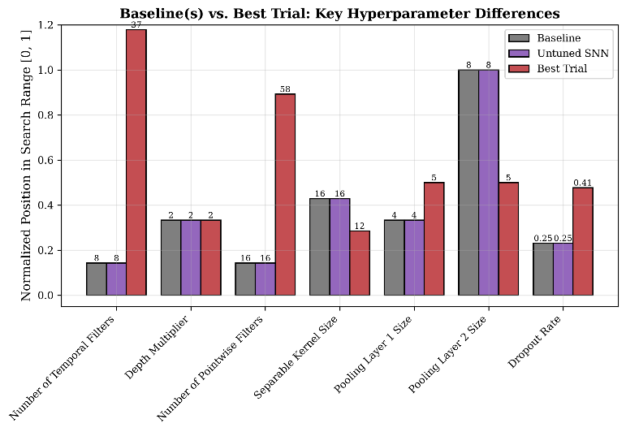
Comparing the best trial to both baselines shows a consistent pattern: nearly every architectural parameter that changed materially got larger, giving the network more capacity to work with. The number of temporal filters rose from 8 to 37 and the number of pointwise filters rose from 16 to 58. Dropout also rose meaningfully, which fits a larger network needing more regularization to avoid overfitting. Separable kernel size moved the other way, shrinking from 16 to 12, suggesting the separable convolution needs a narrower temporal window once the upstream feature maps are already wider. Pooling changed unevenly between the two stages as pooling layer 1 size increased only slightly while pooling layer 2 size dropped substantially. That second change is meaningful since it means the network compresses the time dimension far less aggressively at that stage which preserves noticeably more temporal resolution heading into the classifier. The recovery in accuracy appears to come from a combination of added filter capacity and a deliberate shift toward retaining more temporal detail late in the network, not from a uniform, across-the-board change to pooling.
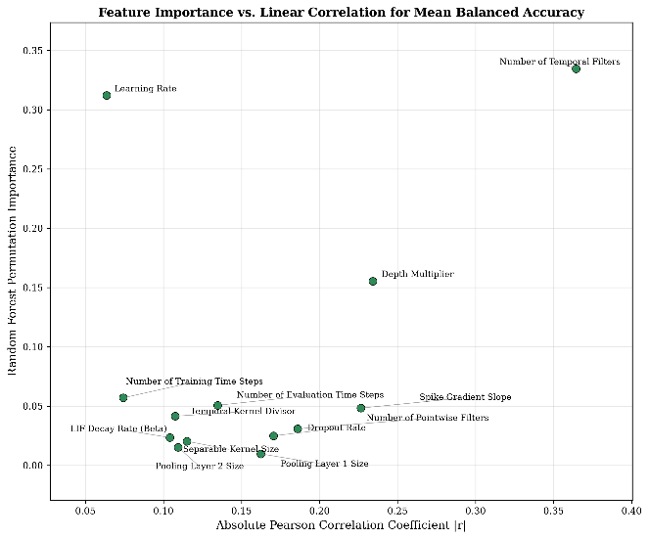
Comparing each parameter's Random Forest permutation importance against its absolute Pearson correlation reveals important information. Temporal Filters scores high on both showing a monotonic relationship where more filters consistently help mean balanced accuracy. Learning Rate has the second-highest importance but one of the lowest correlations, showing a nonlinear relationship that has a sweet spot for maximum performance. Depth multiplier shows a milder version of the same pattern. Everything else clusters somewhat low on both axes showing that accuracy is far more sensitive to filter counts and learning rate than to spiking-specific dynamics or pooling/kernel geometry.
An untuned ReLU to LIF conversion costs 8.2% mean balanced accuracy but is fully recoverable through architecture and hyperparameter tuning. The main change is network capacity as substantially more temporal/pointwise filters plus modestly higher dropout is most important to mean balanced accuracy. Learning rate is also critical but behaves nonlinearly.

